AI-Based Smart Healthcare System for Optimized Ambulance Routing and Predictive ICU Bed Availability

**Ms. Shwetha AN¹, Sreejith S², Manoj P³, Poornima⁴, P Harshad Ali Khan⁵**

|  |  |  |
| --- | --- | --- |
| Sreejith S² Dept. of Computer Science and Engineering (Data Science) New Horizon College of Engineering, India [1NH22CD127@newhorizonindia.edu](mailto:1NH22CD127@newhorizonindia.edu) | Manoj P³ Dept. of Computer Science and Engineering (Data Science) New Horizon College of Engineering, India [1NH22CD064@newhorizonindia.edu](mailto:1NH22CD064@newhorizonindia.edu) | Ms. Shwetha AN¹  Assistant Professor  Dept. of Computer Science and Engineering (Data Science) New Horizon College of Engineering, India [shwetha.an_ds_nhce@newhorizonindia.edu](mailto:%20shwetha.an_ds_nhce@newhorizonindia.edu) |
| P Harshad Ali Khan⁵ Dept. of Computer Science and Engineering (Data Science) New Horizon College of Engineering, India [1NH22CD077@newhorizonindia.edu](mailto:1NH22CD077@newhorizonindia.edu) | Poornima⁴ Dept. of Computer Science and Engineering (Data Science) New Horizon College of Engineering, India [1NH22CD081@newhorizonindia.edu](mailto:1NH22CD081@newhorizonindia.edu) |

***Abstract --* Effective healthcare management is important for improving patient outcomes, reducing delays, and ensuring optimal resource allocation. Recent study emphasizes the use of artificial intelligence and modern technologies to address crucial concerns. Neural networks and metaheuristic algorithms such as genetic algorithms and multilayer perceptrons can be used to optimise hospital transport logistics, reducing delays by up to 42% without increasing resource requirements. Smart ambulance systems increase emergency response by merging real-time traffic data, patient vitals, and hospital capacity to help with routing and treatment decisions. These solutions improve in-transit care by allowing physicians and paramedics to communicate in real time and reduce door-to-needle time. Furthermore, IoT-enabled scalable smart city infrastructure enhances service allocation and emergency access. Meanwhile, machine learning-based intensive care unit admission methods, such as "heartbeat," improve patient classification precision, make decisions easier, and reduce the cost burden on insurers and hospitals. These innovations represent a data-driven shift in healthcare delivery towards more patient-centred, responsive, and intelligent care.**

***Keywords:* Healthcare Management, Artificial Intelligence, Smart Ambulance Systems, Neural Networks, and Machine Learning, ICU Admission Optimization, and Real-time Patient Monitoring**

# INTRODUCTION

Healthcare systems have gradually switched their attention to patient-centred care, emphasizing the need of timely and efficient service delivery. Lenz and Reichert divide hospital operations into two categories: medical treatment processes, which directly affect patient health, and organizational processes, which facilitate the execution of medical treatments [1]. The smooth operation of these organizational systems, notably Intra-Hospital Patient Transportation (IHPT), is critical for ensuring prompt clinical interventions. IHPT, or transporting patients between hospital units such as wards, diagnostic rooms, and surgery theatres, is an important but often overlooked logistical operation [1]. Given its frequency of use, IHPT has a significant impact on treatment efficiency and patient satisfaction [1]. Several studies have highlighted its significance by highlighting the negative repercussions of transportation inefficiencies. For example, one cross-sectional investigation of 191 IHPT occurrences discovered that 31% resulted in unfavourable outcomes, while another study indicated that 36% of 288 brain-injury transport cases had at least one major complication [1]. These adverse effects are frequently associated with long wait times caused by insufficient transportation capacity and poor resource planning [1]. Kropp et al. underline the importance of real-time, data-driven monitoring to optimize IHPT workflow and reduce delays [1]. Aside from hospital interiors, exterior emergency services face growing issues as a result of expanding urbanization and increased road congestion. According to statistics, ambulance delays cause around 30% of deaths in traffic accidents and 20% of emergency medical deaths, making rapid response critical [1]. This emphasizes the critical need for smart, technology-assisted solutions in emergency medical services. The Internet of Things (IoT) has emerged as a disruptive force in healthcare, with capabilities that go far beyond device interconnectivity. IoT allows for predictive and adaptive healthcare delivery models by collecting intelligent data and monitoring it in real time [2]. When combined with machine learning, it allows for the rapid detection of key patterns and abnormalities that may be beyond human recognition, hence improving emergency response [2].The Smart Ambulance System is a crucial breakthrough enabled by IoT, particularly in the context of smart cities. These technologies attempt to improve care and minimize emergency

response times by integrating real-time communication between ambulances, hospitals, and patients [3]. The smart ambulance platform typically includes three interfaces: the admin interface, which monitors patient location and request data; the ambulance interface, which provides real-time maps of nearby hospitals and traffic conditions; and the user interface, which allows patients or caregivers to initiate emergency requests and share their location and medical status [3]. Furthermore, the smart ambulance concept uses modern technology including biomedical sensors, body area networks, and real-time data sharing to provide care while in transportation and reduce delays [4]. However, reliable connectivity is required for high-resolution video streaming and two-way communication between ambulances and hospitals. Traditional LTE networks frequently fall short of delivering the required speed and latency, pushing researchers to investigate 5G-based communication frameworks for improved performance [4]. Furthermore, smartphone applications have been created to allow users to locate the closest available ambulance, estimate the traffic-adjusted journey time to local hospitals, and automatically determine the most efficient route [4]. The Ambulance Routing Problem, a fundamental logistical difficulty in emergency medical systems, is at the heart of these innovations. Efficient routing algorithms are required to guarantee ambulances arrive on time and deliver patients to the most appropriate healthcare institutions [5]. The problem stems from a complicated interaction of time sensitivity, geographical limits, and resource availability. Addressing this issue is critical, as saving time in transportation can have a direct impact on survival rates, particularly during life-threatening events [6]. The ability to dynamically change routes in response to real-time traffic data and hospital capacity improves both emergency response time and quality of service.

1. LITERATURE REVIEW

Several surveys have been undertaken on Smart Ambulance systems and Smart Cities, and several projects have emerged since the year 2000. While some of these works suggest different solutions, they frequently have a same goal with Smart Ambulance systems: enhancing emergency response efficiency in urban settings. However, many of these projects fail to capitalize on current technological breakthroughs. Smart City applications have been extensively studied in the literature, with a focus on layered analysis of systems, software, hardware, availability, durability, stability, and maintenance. According to [9], Smart Cities are becoming increasingly important as a result of rising urban migration. By 2040, almost 70% of the world's population is predicted to live in cities.

This demographic shift brings various issues, including traffic congestion, restricted parking, and resource allocation. Addressing these issues necessitates proactive urban planning supported by data-driven decisions. ICT is critical to Smart City development because it allows for real-time data collection and administration. ICT enables the development of responsive apps for critical services such as online banking, remote video communication, and e-commerce. The notion of "Intelligent Cities" expands on Smart City infrastructure by encouraging industrial growth and enhancing inhabitants' quality of life through better resource use, transportation, healthcare, crime reduction, and job creation [1].

Big data analytics has further changed urban planning by revealing patterns and insights in massive datasets. These insights not only help with current decision-making but also enable predictive planning. Machine learning and data mining are being used in traffic and parking management to estimate future behaviour and improve infrastructure performance. These technologies are being used to power applications such as Smart Traffic Management and Smart Parking Systems [3]. In [10], trauma is identified as a main cause of death in metropolitan areas, particularly in underdeveloped countries. Delays in transferring patients to emergency centres worsens trauma outcomes. To address this issue, emergency event reporting systems have been developed, in which smartphones detect and notify local emergencies. These devices send real-time data to emergency services and ambulances, including location, casualty count, and injury kinds, allowing for more efficient routing to hospitals. The authors of [11] stressed the importance of sophisticated healthcare systems and recommended a Smart Ambulance system including IoT and big data technologies. Their goal was to lower mortality rates by allowing for faster and more informed reactions to medical emergencies. Similarly, [2] described a technique combining IR sensors and mobile applications to manage traffic signals dynamically. — changing red signals to green on an ambulance's route to facilitate a faster arrival at medical facilities the literature also contains extensive discussions about ICU admission methods and resource optimization. Patient eligibility, initial treatment demands, and availability of monitoring equipment are all important admission criteria for the ICU. Early admittance is generally crucial for improving patient outcomes and shortening ICU stays. However, ICU resources are scarce and expensive, requiring efficient and ethical resource distribution. The Society of Critical Care Medicine (SCCM) has established standard ICU levels:

* Level 1: Critically ill, severe cases
* Level 2: Less critical patients
* Level 3 and beyond: Patients with monitoring needs but less intensive care

Misclassification of ICU levels, which is occasionally done purposely to enhance hospital charges, can lead to inadequate care and higher mortality [4,5,7]. Furthermore, Dacosta et al. [6] found that delayed transfers from emergency wards to ICUs dramatically increased fatality rates, several machine learning techniques have been employed to predict mortality, including classic models such as K-Nearest Neighbour (KNN), Support Vector Machine (SVM), and Gaussian Processes. While many of them do not directly give probabilistic outputs, there are methods for converting their results into probabilistic predictions, such as Brier scores [13]. Recently, Yilmazcan Ozyurt et al. presented deep Markov models (e.g., Att DMM) for real-time mortality prediction. These models consistently outperform standard methodologies by continually monitoring patient data and providing dynamic risk assessment, essentially acting as early warning systems.

1. PROPOSED SYSTEM

The proposed system uses a combination of intelligent routing algorithms and predictive models to improve ambulance efficiency and ensure timely ICU bed availability. The system addresses the issues that emergency services confront by utilizing advanced techniques such as Dijkstra's Algorithm, A*, K-Means Clustering, and LSTM (Long Short-Term Memory) neural networks. We will explain the system in two parts: the Ambulance Routing Module and the ICU Bed Prediction Module.

1. **Ambulance Routing Module**

The Ambulance Routing Module is meant to optimize an ambulance's journey, ensuring that it follows the shortest and most efficient route to the hospital while taking into account real-time traffic data. This routing system is comprised of three main components: Dijkstra's Algorithm, A*, and K-Means Clustering. Each component serves a distinct purpose that adds to the overall system's performance.

* Dijkstra's algorithm (base case routing):

Dijkstra's Algorithm is a well-known method for calculating the shortest path between nodes in a graph. In our system, it acts as the base case routing algorithm, calculating the shortest path between the ambulance's current location and the target hospital based solely on distance and time. This technique is very useful when there is little traffic data available or when real-time updates are not being used. It serves as the starting point for more complex improvements.

* ***A Algorithm (Weighted Routing Based on Traffic Time) **:***The A Algorithm is an adaptation of Dijkstra's Algorithm in which the pathfinding is improved with a heuristic function. In the context of ambulance routing, A* estimates the ideal route by taking into account both the actual trip distance and the predicted traffic time. This enables the ambulance to avoid congested locations by utilizing real-time traffic data, such as accidents, road closures, and peak-hour traffic. The A* Algorithm's ability to employ weighted values for traffic situations sets it apart from normal Dijkstra's in urban areas, where real-time data is critical for route planning.
* **K-Means Clustering (Grouping Nearby Hospitals)**:  
  K-Means reduces the computational load and improves routing efficiency. Clustering is a technique used to group hospitals that are geographically adjacent to one another. This lowers the ambulance's search space by swiftly identifying clusters of hospitals to choose from based on the ambulance's current location and the patient's health. Clustering hospitals into zones helps the system to identify the nearest hospital cluster, decreasing processing time and improving routing efficiency. Furthermore, this avoids the need to re-evaluate distant hospitals, which would be computationally costly.
* **Live Route Mapping Using GIS APIs**:  
  The solution uses Geographic Information solution (GIS) APIs to provide real-time mapping and visualization of the ambulance route. This module provides live updates, allowing emergency responders to monitor the ambulance in real time. GIS also plays an important role in informing the system about road closures, accidents, and detours, ensuring that the ambulance is always on the best feasible path depending on the current conditions.

1. **ICU Bed Prediction Module**

The ICU Bed Prediction Module uses LSTM neural networks to forecast the availability of ICU beds at the destination hospital at the estimated time of arrival (ETA). This prediction algorithm combines historical ICU bed occupancy data, as well as real-time inputs such as time of day and seasonal trends, to estimate if an ICU bed will be available when the ambulance arrives.

* **Inputs to the ICU Prediction Model**:

Several important inputs that affect ICU bed occupancy are taken into account by the LSTM-based ICU prediction model:

* + **Past Bed Occupancy Data**: The LSTM model is trained using historical ICU bed occupancy data. The system examines historical patterns in bed utilization, including peak times, hospital admissions, and discharges.
  + **Time of Day:** The prediction is influenced by the anticipated time of arrival of the ambulance. Due to personnel and patient inflows, there may be fewer ICU beds available during specific times, like as weekends or late evenings.
  + **Seasonal Trends**: Owing to things like flu epidemics and accidents, hospitals frequently see seasonal variations in bed occupancy. To increase prediction accuracy, the model takes these seasonal trends into account.
* **LSTM Neural Networks for Prediction**:  
  LSTM is a deep learning model that performs exceptionally well when analysing time series data. When predicting ICU bed availability based on historical data, the LSTM model's strength is its capacity to retain long-term dependencies. The network can recognize trends and generate precise predictions using current input data since it has been trained on a dataset of intensive care unit occupancy over a period of months or years.
* **Output of the ICU Prediction Model**:  
  The anticipated availability of intensive care unit (ICU) beds at the ambulance's expected time of arrival (ETA) is the result of the LSTM model. The technology notifies the ambulance crew if a bed is likely to be available so they may make appropriate plans. The system can offer additional quick fixes, including starting remote care or moving the patient to a less critical care unit, or it can divert the ambulance to another hospital if no beds are anticipated to be available.
  + **Conceptual Flow of ICU Bed Prediction**:  
    **Figure 1** Demonstrates the conceptual flow of the LSTM-based ICU prediction model. The algorithm forecasts ICU availability using past bed data and the predicted arrival time of the ambulance at the hospital. By continuously monitoring bed occupancy, the system can update its forecasts in real time, guaranteeing that emergency services are ready to manage patient arrivals.

**3. Integration of Modules**

The system combines the Ambulance Routing Module and the ICU Bed Prediction Module into one single platform. The routing module optimizes the ambulance's travel, while the ICU prediction module assures that a bed is available when the ambulance arrives. These modules work together to provide a holistic solution for emergency medical services, combining AI-based decision-making with real-time data inputs to save lives by lowering response times and assuring hospital readiness.

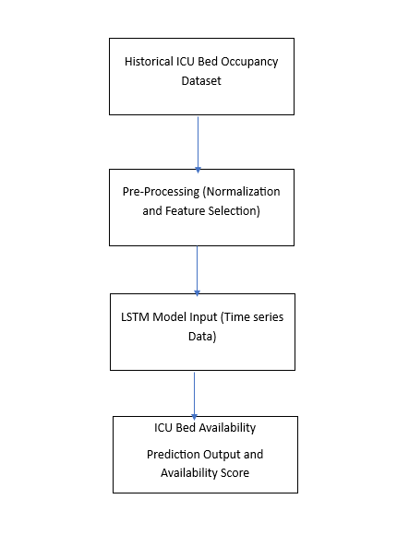

**Figure 1**: shows the conceptual flow of our LSTM-based ICU prediction model, which uses previous bed data to forecast ICU availability at the expected arrival time.

This technology is intended to give an efficient, data-driven answer to the problems encountered by urban ambulance systems. Optimizing both routing and predicting ICU bed availability considerably enhances the likelihood of a successful medical result for patients requiring emergency treatment.

IV. RESULTS AND DISCUSSION

This section presents the outcomes of implementing the AI-Based Smart Ambulance Routing with ICU Bed Prediction system, as well as a discussion of its effectiveness, user interface, and module integration. We'll also discuss how each module helps to improve emergency reaction times and decision-making.

**1. Login and Welcome Module**

The Login & Welcome Module simplifies the user authentication procedure for two sorts of users: administrators and first responders. Administrators have access to configuration settings and system analytics, whereas first responders can use the system to handle ambulance route and hospital data.

**UI Element: Welcome + Role Display**

Once logged in, the system shows a personalized welcome message along with the user's role (for example, "Welcome, First Responder" or "Welcome, Admin"). This immediate response guarantees that the user understands their level of access within the system.

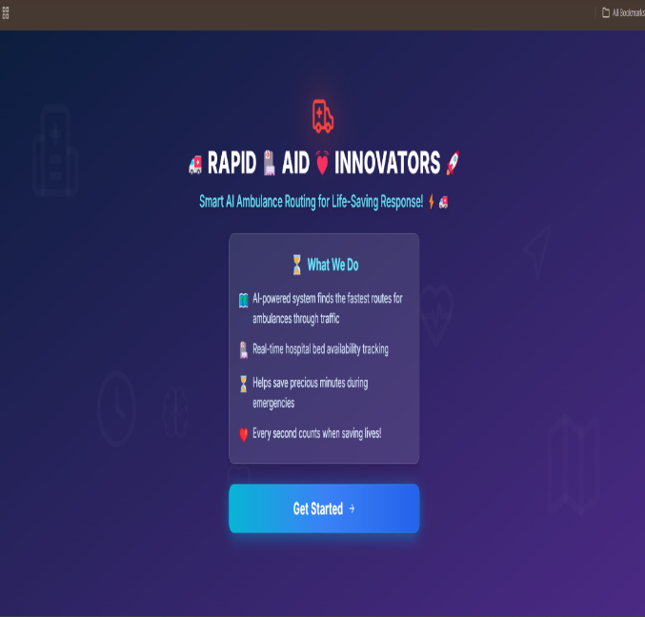

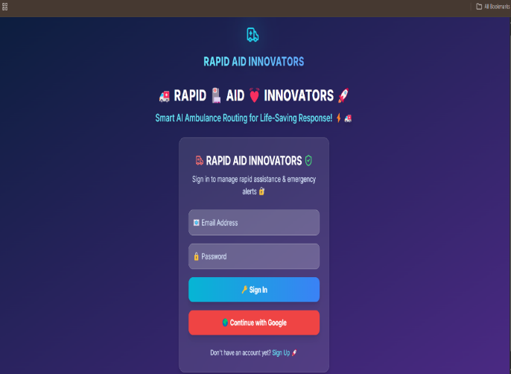

**Figure 2: Login and Welcome Interface**  
*The figure below depicts the Login page, where users authenticate and, after successful login, the Welcome message with role display appears.*

**2. Emergency SOS & Smart Routing**

When the system receives an emergency SOS, it determines whether to use ground or air transport based on the location and urgency. The AI-powered system then computes the Route ETA (Estimated Time of Arrival) and recommends the best hospital based on criteria such as ICU availability, hospital distance, and traffic conditions.

**AI Hospital Recommendation**

The hospital recommendation system takes into account traffic statistics, historical bed occupancy, and the real-time availability of ICU beds. It employs a weighted technique to provide the optimal routes for the ambulance to go.

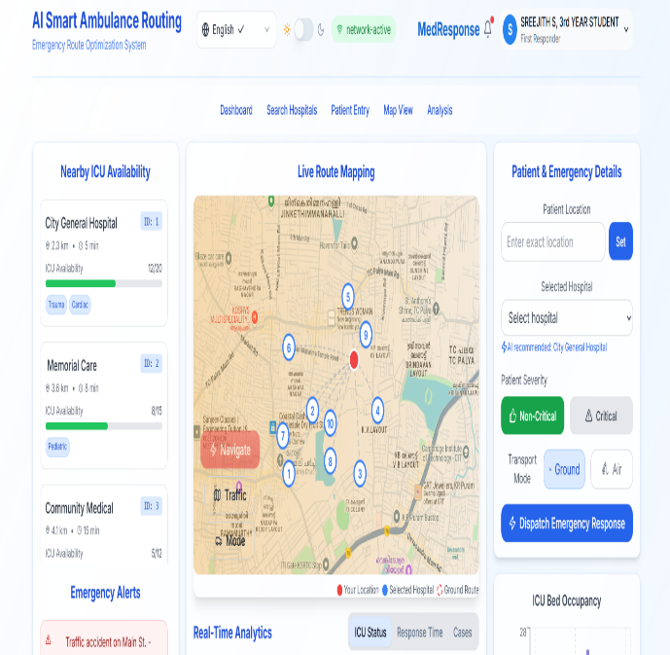

**Figure 3: Emergency Routing Interface**  
*This graphic depicts the emergency SOS interface, which includes options for selecting transfer type (ground/air), real-time ETA, and AI hospital suggestions.*

**3. Hospital Search Module**

The Hospital Search Module enables users to find hospitals by name, location, and specialty. There are other options that allow you to narrow down your search based on 24/7 hospital and ICU bed availability.

**Search by Name, Location, and Specialty**

This feature ensures that responders can rapidly locate the appropriate hospital for the patient's condition, whether it's a general hospital or one that specializes in certain therapies. The search mechanism is straightforward and quick, with real-time updates.

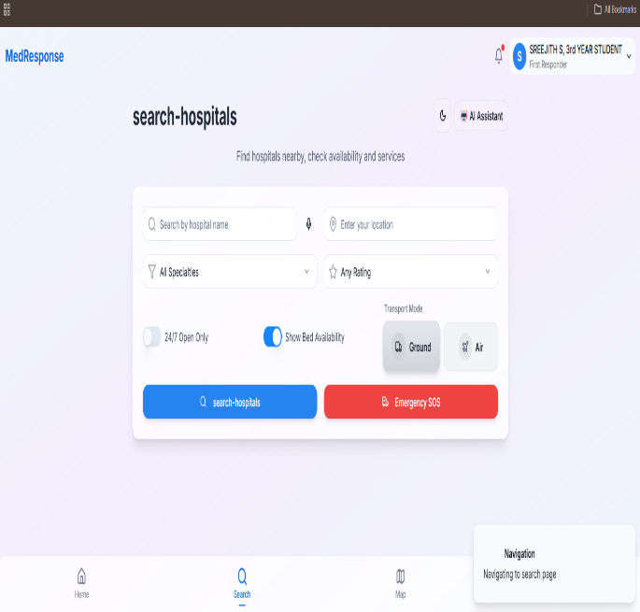

**Figure 4: Hospital Search Interface**  
*The graphic below depicts the Hospital Search Interface, which allows users to filter hospitals based on name, location, and specialty.*

V. CONCLUSION

Based on the findings and study, the suggested Smart Ambulance System with AI-based routing and ICU bed prediction represents a possible solution to the challenges of emergency response efficiency. By implementing advanced algorithms such as Dijkstra's and A* for base case routing and traffic time-weighted optimization, the system assures faster ambulance routing and shorter response times. The addition of K-Means clustering to group adjacent hospitals and reduce computational complexity improves the system's capacity to make real-time, correct recommendations. With live route mapping provided by GIS APIs, the ambulance can dynamically change its route to ensure the shortest way to the next available hospital, improving patient outcomes in emergency scenarios. Additionally, the ICU bed prediction module, using LSTM neural networks, makes a major contribution to optimal hospital selection by forecasting ICU bed availability at the predicted time of arrival. This module gives critical insights on hospital assignments by integrating previous bed occupancy data, time of day, and seasonal trends, lowering the likelihood of diversion or delays. This proactive prediction of ICU availability allows emergency responders to guide patients to the most appropriate healthcare institutions, increasing the efficiency of emergency medical services (EMS) and hospital resource allocation. The AI-based hospital recommendation system directs the patient to a hospital with available ICU beds, emphasizing fast and efficient medical care. To conclude, the integration of AI and machine learning technologies in ambulance routing and ICU bed prediction systems represent a significant improvement in the field of emergency healthcare services. This technique not only optimizes ambulance routing in real time, but it also improves the allocation of key hospital resources. With further refinements and real-world testing, the system has the potential to significantly improve emergency medical response times, lower mortality rates, and optimize healthcare resource utilization, all of which contribute to the overarching goal of improving urban healthcare systems' resilience to growing demand.

##### VI. REFERENCES

[1]. T. Kropp, Y. Gao, and K. Lennerts, "Data-based optimisation of intra-hospital patient transport capacity planning," *OR Spectrum*, vol. 2024, pp. 1–54, 2024.

[2]. M. N. Ashmawy, A. M. Khairy, M. W. Hamdy, A. El-Shazly, K. El-Rashidy, M. Salah, Z. Mansour, and A. Khattab, "SmartAmb: An integrated platform for ambulance routing and patient monitoring," in *2019 31st International Conference on Microelectronics (ICM)*, pp. 330–333, 2019.

[3]. T. Akca, O. K. Sahingoz, E. Kocyigit, and M. Tozal, "Intelligent ambulance management system in smart cities," in *2020 International Conference on Electrical Engineering (ICEE)*, pp. 1–7, 2020.

[4]. M. A. R. Abdeen, M. H. Ahmed, H. Seliem, T. R. Sheltami, T. M. Alghamdi, and M. El-Nainay, "A novel smart ambulance system—algorithm design, modeling, and performance analysis," *IEEE Access*, vol. 10, pp. 42656-42672, 2022.

[5]. R. Tluli, A. Badawy, S. Salem, M. Barhamgi, and A. Mohamed, "A Survey of Machine Learning Innovations in Ambulance Services: Allocation, Routing, and Demand Estimation," *IEEE Open Journal of Intelligent Transportation Systems*, 2024.

[6]. Y.-Y. Xu, S.-J. Weng, P.-W. Huang, L.-M. Wang, C.-H. Chen, Y.-T. Tsai, and M.-C. Tsai, "The emergency medical service dispatch recommendation system using simulation based on bed availability," *BMC Health Services Research*, vol. 24, no. 1, p. 1513, 2024.

[7]. Y. Hakverdi, M. U. Gümüs, A. Taştekin, K. Idin, M. Kangın, T. Özyer, and R. Alhajj, "Enhancing ICU management and addressing challenges in Turkey through AI-powered patient classification and increased usability with ICU placement software," *IEEE Access*, 2024.